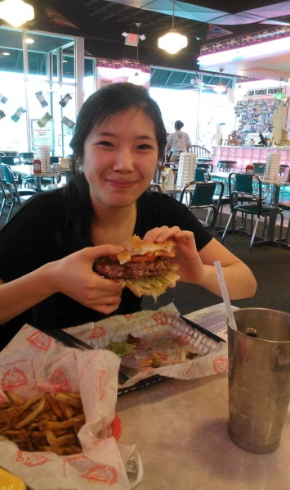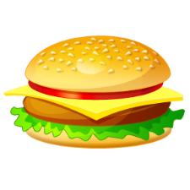

**Take a Bite of This!**

The hard work and commitment put into the fundraising effort has paid off! The fundraiser this Thursday was a success. We made $65.25 and also indulged in massive hunks of meat and creamy harmonious refreshments. Val magnificently completed the Cheeburger Challenge! Congratulations Val! The class has raised a total of $388.25 and 258 items donated… wow ! The teachers and students are going to be thrilled when they receive new supplies and books. A small act of kindness can go a long way!

Never underestimate your power to make a difference!

**Look How Far We’ve Come!**

Oh how time flies when you are having fun! It feels like just yesterday we were sitting in Dr. Pan’s class for the first time, camouflaging ourselves into the walls to dodge Dr. Pan’s camera. Look how far we’ve come! The semester has been a turning point in our lives, one that will never be forgotten. We can see our peers’ faces glow when they talk about their students and their wonderful classroom endeavors. This week marks the beginning of our full-time attendance in the classroom and the cross-curricular units we have spent weeks planning. Let’s take a closer look…

ACB Newsletter

First Week Teaching Full Time

*April 19, 2013 Volume I, Issue 5*

*“What you teach today may someday light the world”*

“My first week of full time has been a lot of fun (and really tiring)! I can't believe we're almost halfway done. One lesson I taught this week was about mountains, valleys, and canyons and the kid did an activity with sugar cube mountains to show how valleys and canyons are formed. I think they had a lot of fun.”

-Danielle Reilly

“This week has been crazy. I've learned so much and I've had so much fun with the all the kids. For the last two days, I've been teaching about the 3 states of matter and the changes of state. They didn't quite get it the first day that I taught the lesson, but when we went over it the next day, they had pretty much gotten it. We did this kinesthetic activity where they pretended to be water molecules and they acted out each state of matter. They REALLY liked being a gas. (not surprisingly)”

-Allison Au

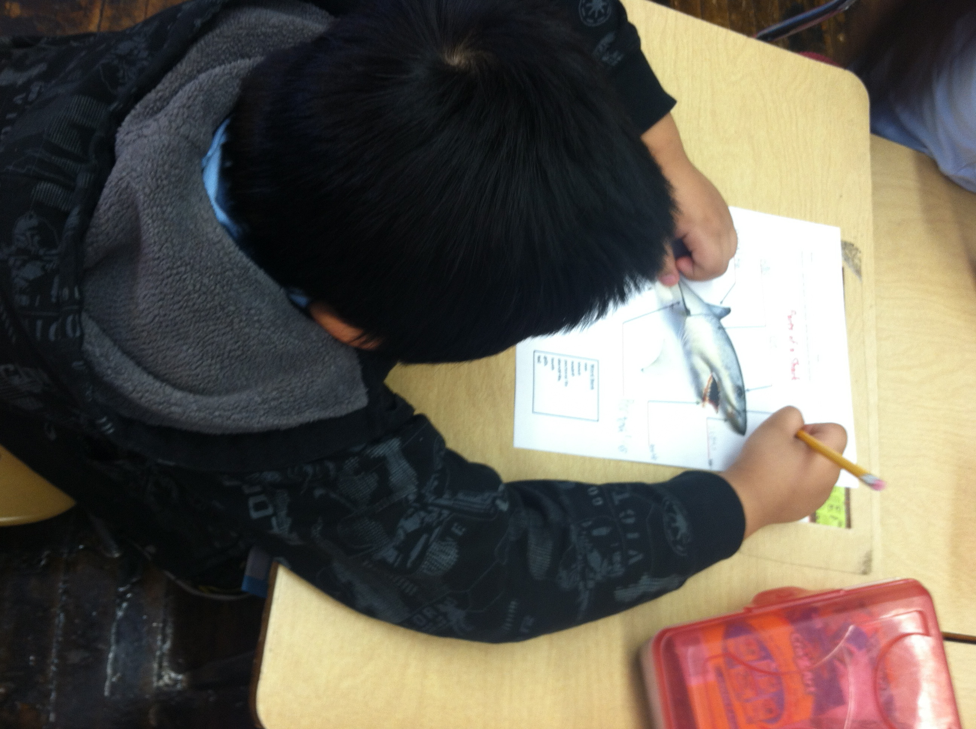

``

Ms. Venice and Ms. Wuest’s student working hard labeling his shark diagram!!

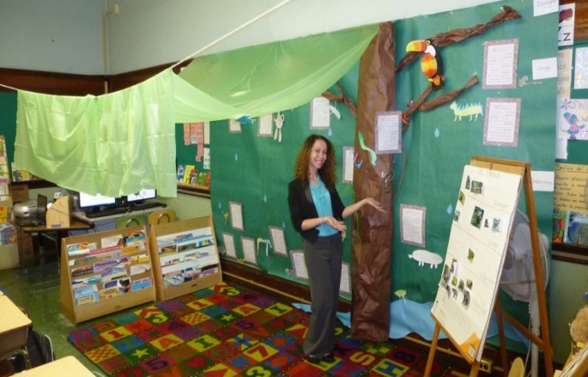-

My first week was hard work but very exciting and so much fun. I love getting the opportunity to really get to know the students and teach in my unique way and see the students learn. Going to the zoo was so great! The kids were so excited and it made me happy to see that, plus I love going to the zoo on my own anyway! I did my observed lesson on the 4 levels of the rainforest and some of the animals that live there. I brought my guitar in and we sang a song about it that the kids will perform the last day for their parents. I showed some awesome videos of animals and read a big book in Spanish. I asked the students to tell me all of the animals they remembered from those sources and we put pictures of them on a chart in the right layers. Then each student was given an animal to draw and they had to place it in the correct layer when they were done. In Kathy's extension lesson after, the students wrote about their animal. We put their work in our class rainforest!

-Jessie Schepis

“My first week of teaching has been unbelievable! I have learned so much about the amount of patience, flexibility, and dedication that you need as a teacher. I also realized how it is important to still take care of yourself over the course of the school week, because if you don't, then you will burn out. It's really easy not to, but I think it's so important to take a few minutes for yourself each day so that you do not feel like you are running on empty! A lesson I taught this week was about opinion writing. Throughout the week, my students wrote opinions about whether or not they like ice cream or water ice, and they had to explain why. Their pieces came out really great, and I can't wait to see how their published work turns out!”

-Michelle Sanders

*“A good teacher is like a candle- it consumes itself to light the way for other”* – Author Unknown

**Let’s Review…….**

水果  [Shuǐguǒ] “fruit”

菜  [cài]    “vegetable”

**Mā mā mà mǎ mā?**

Ma !!!

*“Have fun with the students – They are in your life to teach you something.”*

-Ms. Natasha Agrawal

Did the mother scold the horse ?

On April 4, 2013, our class attended Dr. Jean Wong’s ELL workshop. Mrs. Agrawal, the ESL teacher at Robbins, also made a presentation which examined the ELL students at Robbins . Dr. Wong began the workshop by putting us into the shoes of our ELL students. She spoke solely in Mandarin Chinese for the first fifteen minutes of the workshop. What an eye-opening experience! It really provided us with insight on how truly gifted these students are. Dr. Jean Wong brought to our attention that these students are an asset to the classroom! Dr. Jean Wong continued the workshop by explaining her background as a 1.5 generation child and her own ESL experience. She talked about her childhood growing up in a non-English speaking home, and living in a Laundromat. She and her sister wished for composition notebooks when they were children however, their family could not afford them. Dr. Wong’s mother made them brown paper notebooks from the extra wrapping paper in the laundry shop, and they had to draw in their own lines with a ruler. Our class presented our own brown paper bag notebook to Dr. Wong as a gift. The gratitude Dr. Wong expressed after receiving the gift was touching. The notebook is a treasure to Dr. Wong, it is a reminder of her roots. Dr. Jean Wong will always remember our class and our act of kindness and our respect and gratitude for her heartrending presentation. I am so happy we were able to express our appreciation to Dr. Wong, she is truly enlightening.

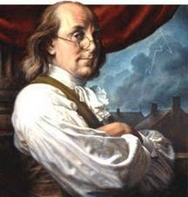

“My favorite memory was our 5th grade show that we did at the end of 5th grade! It was really fun because I got to dance in front of the whole school and I had never done that before. It also gave me an opportunity to work with other students who shared my passion for dance that I had never worked with before in the regular classroom!”

-Michelle Sanders

“My favorite memory was in 2nd grade. Every year, my teacher would organize a play, which was performed at the end of the year in front of the school & parents. The cast included only my class and we had so much fun making paper mache props and memorizing every line. That year, we performed the Lion King and I remember having to sing the solo for Can You Feel the Love Tonight, but I was a hyena, which is kind of strange now that I think back on it.”

-Allison Au

“One of my favorite memories from elementary school was in third grade, when I got to read a biography of my choice and dress up like the person to do an oral report about her. I chose Nadia Comaneci, because she was (and still is) my favorite gymnast. It was so much fun to get to dress up and see all my friends and classmates dress up like the people they did their reports on!”

-Susie DaQuila

**What is your favorite memory from elementary school?**

*"Tell me and I forget. Teach me and I remember. Involve me and I learn*”."

*“To teach is to touch a life forever”*- Author Unknown

|  |  |
| --- | --- |
| **Important Upcoming Dates** | |
| April 23, 2013 | RAL Process Interview and Literature Circle Assignment Due |
| May 5, 2013 | ELE E-portfolio and Top Reflection Assignment Due |
| May 8, 2013 | SOM Oral History Interview Due |

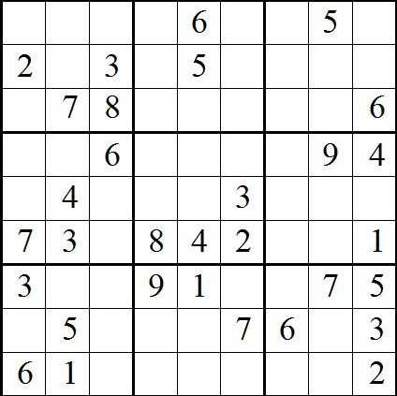

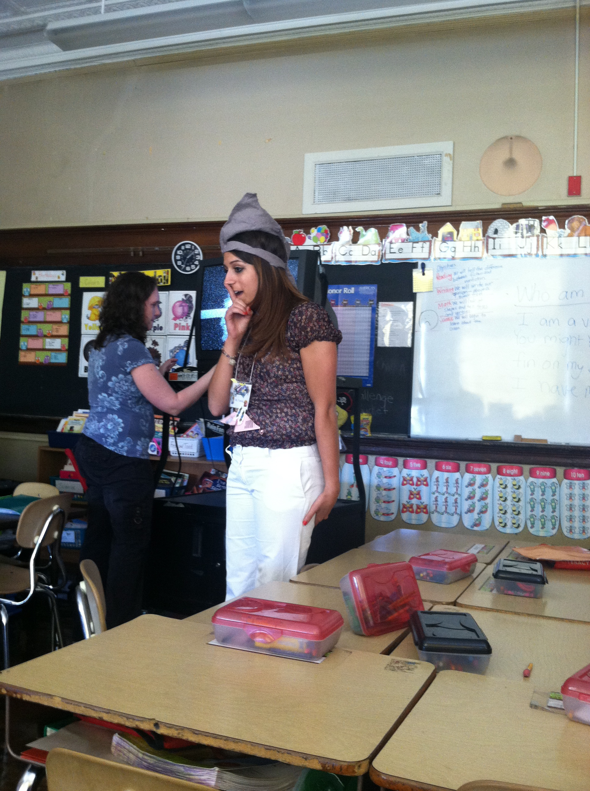

What is going on in this picture?

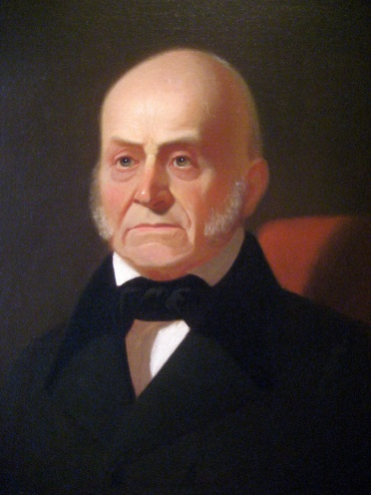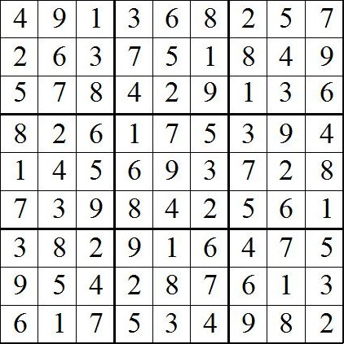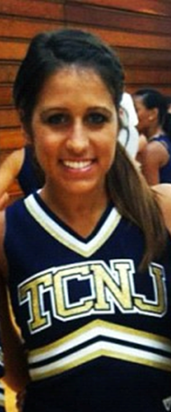

“*If your actions inspire others to dream more, learn more, do more, and become more, you are a leader.”*

**Your text here**

**Your text here**

*Hello my name is Bianca Venice and I am a junior elementary education and math major .I am from Wall, New Jersey. I have two siblings, a younger brother who is fourteen and an older sister who is twenty-two. My ultimate dream is to make a change in this world through my teaching. I will foster my students to believe in themselves by setting high but achievable goals for them. My students will be taught to pursue their dreams, and they will learn that nothing will be impossible for them to achieve. Teachers are given a gift that should not be taken for granted. My mom was a strong influence on my dream. She always encouraged me to dream big and that all I needed was hard work and to believe in myself. I want other children to be taught this same wisdom. Some question why teaching.. why not dream bigger? My dream is a big dream that I will continue to strive for.*

*Growing up I always knew I wanted to either be an elementary school teacher or a veterinarian. After fainting during a science lesson about brain injuries in fourth grade I soon realized that may not be the best career path for me. So I decided from then on that teaching was going to be my passion and that was the path I followed. Math has always been my forte since I was a young child, so I decided I wanted to study math in college as well. I aspire to use my strong math knowledge to construct a solid math foundation in my students. I want to instill in them the love and passion I have for math. Evident from my one childhood dream to become a vet I have always been an animal person. My two best friends are my Labrador Retriever and my German Sheppard. My second grade teacher is the incredible woman who initially inspired me to become a teacher. Her undeniable passion for her job and her love for all of her students remains fossilized in my mind. She shared my love for animals, and we frequently learned about all different types of animals and her various classroom pets. I would like to incorporate my knowledge and love for animals in my own classroom. I wish to convey to my students my passion and heart for learning but also life. My students will adopt an optimistic attitude and will be lifelong learners.*

*Hello, my name is Heather. I am twenty-two years old and I am an elementary education and women and gender studies major. My birthday is September 13th. I am aspiring to be an elementary school teacher. I was born and raised in New Jersey. I have a younger brother and a dog. I love to be outside doing activities such as hiking, bike riding, and running. When I am not in school I love to spend time with my family and friends. I went to Hunterdon Central Regional High School where I played on the varsity field hockey team all four years. I love being in the classroom and learning new material to help me for when I become a teacher. My favorite food is ice cream. My favorite season in the summer because I love to be in the sun. When I finish school, I’d like to be a successful teacher. My favorite book is Something Borrowed and my favorite movie is Pitch Perfect.*

Meet the Authors! 