 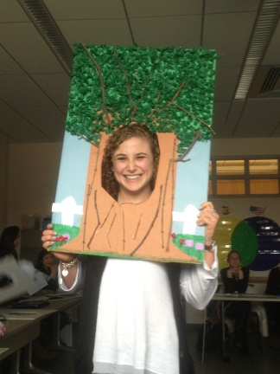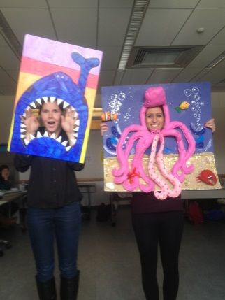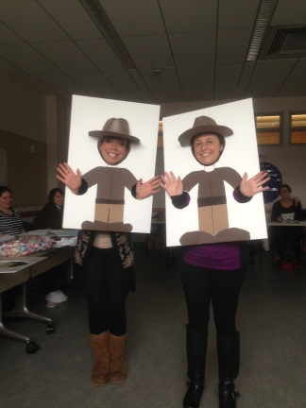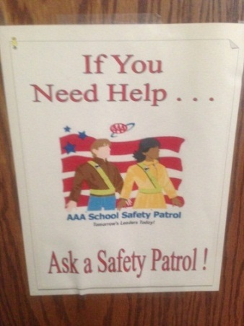

On Friday, March 8, Carroll Robbins Elementary School celebrated Read Across America (Dr. Seuss’ birthday) and Black History Month. Many events took place throughout the prior weeks centered on these two occasions, which were a great way to promote knowledge and excitement throughout the school! Students read stories and researched information about influential people that made a difference in the rights of African Americans. The staff of Carroll Robbins created a scavenger hunt pertaining to Dr. Seuss books. Students had a blast searching the halls for the items on their scavenger hunt list! Prizes were awarded to the first class that completed the scavenger hunt. Students were also recognized for exceptional artwork and writing. Performances were given during the assembly, including an animated story about Harriet Tubman, a step routine to a Dr. Seuss book performed by the Robbins steppers, and dance lessons given by Mrs. Gregory. This assembly was a fantastic way for the school to come together to celebrate two very important holidays!

## Read Across America/ Black History Month Assembly!

Contents

**Welcome Back! 1 Read Across America! 1**

**Upcoming Events 1**

**Welcome Spring! 2**

**Foam Board Cutouts 2**

**Safety Patrol 3**

**Earth Day 3**

**St. Patrick’s Day 4**

**Crunch Time 4**

## Upcoming Events

* ELE Midterm
* Learning Centers
* Teaching Unit!

Welcome back from Spring Break everyone! It’s been a long semester so far, and we are sure everyone appreciated having a nice week off! Because we were off for a week, this newsletter combines things from this past week, as well as the week before. Classes at Robbins Elementary and Dr. Pan’s class are getting ready for the last couple months of school. Can you believe our unit is due in just a couple of weeks? This week Dr. Pan’s class finished their foam board cutouts for Dr. Hornberger. We all had a blast wearing and presenting them!

## Spring Break Activities!

Jessie- “I slept a lot, ate good food, hung out with my friends and family, and had two successful interviews- one for substitute teaching and one for a summer camp job!”  
Susie- “I caught up with friends that were also home on spring break.”  
Valerie- “I went to the MET, worked, took the PRAXIS, and slept!”  
Danielle R- “I spent a lot of time with my family, especially my niece and nephew.”  
Michelle S- “I spent a lot of time with my family and going shopping.”  
Allison- “I hung out with friends and ate a ton of food! I took the elementary praxis too!”  
Bianca- “I hung out with my dogs mostly, and friends and family of course! I also ate a lot!”  
Bryanna- “I went to Punta Cana!!”

# Welcome Back!

Kelly Hardman

Michelle Delahanty

March 22, 2013

Volume 1, Issue 3

Fun at Robbins Elementary!

ELE Newsletter

Page 2 of 4

This past Tuesday Dr. Pan’s class revealed their foam board cut outs to each other and to Dr. Hornberger. Everyone did a great job! The cutouts were extremely creative and will definitely be an asset to support the teaching of our units! Some ideas to incorporate these projects in the classroom were to use the cut outs in an anti- bullying skit or have students present research while holding them. Other students said they will center their bulletin board on pictures of the students using the cut outs. While presenting them, facts were recited, poems or stories were told, and even a few songs were sung! It is no question students will have a lot of fun using these!

## Foam Board Cutouts!

**March comes in like a Lion, and goes out like a lamb!**

March roars in like a lion,  
So fierce,  
The wind so cold,  
It seems to pierce.  
The month rolls on  
And spring draws near,  
And March goes out  
Like a lamb so dear.

This week marked the official start of spring, though you may not be able to tell by the weather! Mrs. Soles introduced this poem to her second grade bi-lingual class while the month of March approached. Not only is this a cute poem to teach students, but it is also something Mrs. Soles used to incorporate into her fairytale unit. Each day one student is chosen to look out of the window and report if it is a “lion or lamb” like day. Throughout the month of March, lion and lamb like days are tallied. Mrs. Soles’ class colored and cut out a picture of either a lion or a lamb. Based on the animal they cut out, fairytales were written with the lion or lamb as their main character. Mrs. Soles had her students create a rough draft of these stories and were later published on lined paper. These stories were graded according to the rubric Mrs. Soles had created and hung in the hallway for the school to see! Great work, Mrs. Soles’ class!

## Welcome Spring!

**Remember This?!!**

A married couple was arguing over who should make the [coffee](http://www.christian-jokes.net/Jokes/Bible-Humor/273-Who-makes-the-coffee.aspx). The wife claimed there was an excerpt in the Bible that stated men should make the coffee. She took the Bible out and pointed to… HEBREWS!

An example of a “lamb” fairytale.

## Have No Fear! Safety Patrol is Here!

The administrators and staff here at Carroll Robbins get the students involved in many activities. In order to keep the school safe, a group of students are selected to be the “safety patrol team.” Their job is to patrol the hallways as well as the doors before and after school. These students are nominated by their homeroom teacher based on their independence and positive behavior. This is a great way to help young students develop leadership and responsibilities, as they feel a sense of empowerment and are motivated to take their job seriously. The school safety patrol leaders are depended on to keep the staff, students and visitors of Carroll Robbins safe!

ELE Newsletter

Page 3 of 4

### **What are some ways to incorporate Earth Day in the classroom?**

**Jessie and Kathy**  
 “For our unit Kathy and I are going to make found object sculptures of animals to show a way to recycle to reduce waste. We are making a bulletin board about trees. I made a big tree to put in the middle. On one side will be the students' labeled pictures from my lesson on the parts of tree. The other side will be the students' work from Kathy's lesson on why trees are important.”

**Susie and Danielle R**  
“We will probably do something for Earth Day incorporating recycling and protecting and conserving natural resources.”

**Valerie and Allison**  
“Allison and I are teaching a unit on water and we wanted to do our last lesson on water conservation. We could talk about how lack of water affects the Earth, specifically plant life.”

**Michelle and Sabrina**  
“Sabrina and I are teaching a unit on life cycles so we could talk about the importance of trees to the Earth.”

**Bianca and Heather**  
“With our unit we can talk about taking care of our Earth (the ocean specifically).”

**Bryanna and Christine**  
“Our unit is about natural resources so we could do something having to do with preserving the natural resources by taking care of Earth.”

## Earth Day is Coming Up!

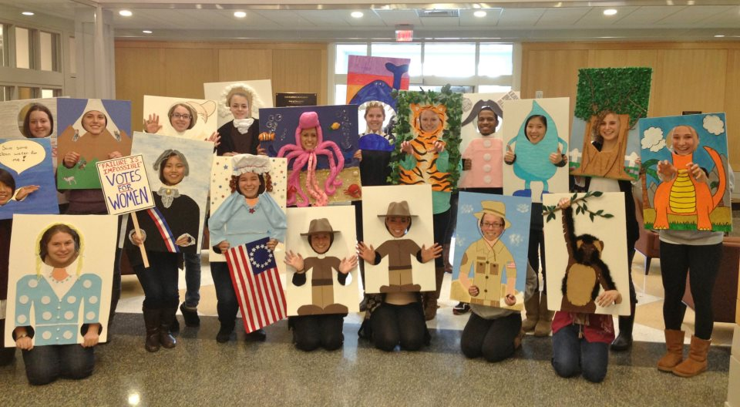

## St. Patrick’s Day

Celebrated on March 17, St. Patrick’s Day is observed in the United States and around the world in honor of St. Patrick. Although the religious holiday has been around for over one thousand years, new traditions have been established. Traditionally, folks gather at church followed by a feast of Irish bacon and cabbage. Many Americans now eat corned beef and cabbage, an “Americanized” version of this hearty meal. Children closely relate this holiday to leprechauns, rainbows, and pots of gold, making this historical event a magical day. Students in Mrs. Soles’s class had the chance to research leprechauns and write one piece of information they learned! The third floor of Robbins Elementary had a beautiful poster for St. Patrick’s Day, complete with four- leaf clovers and lots of sparkle.

**Some great books to incorporate into a lesson about St. Patrick’s Day:**  
The Luckiest St. Patrick’s Day Ever! by Teddy Slater  
Hooray for St. Patrick’s Day! by Joan Holub  
St. Patrick’s Day Alphabet by Beverly Barras Vidrine

We have many assignments coming up in the near future! Keep preparing ahead, stay organized, and take deep breaths…You’ll be fine!

- Learning center  
- Midterm  
- Pre- assessments for unit information  
- Unit objectives  
- Begin creating rubrics to use throughout your unit  
- Create lesson plans  
- Bulletin board

**Happy Teaching!**

**ELE Newsletter**

**Page 4 of 4**

**Happy Teaching!!!**

## Crunch Time