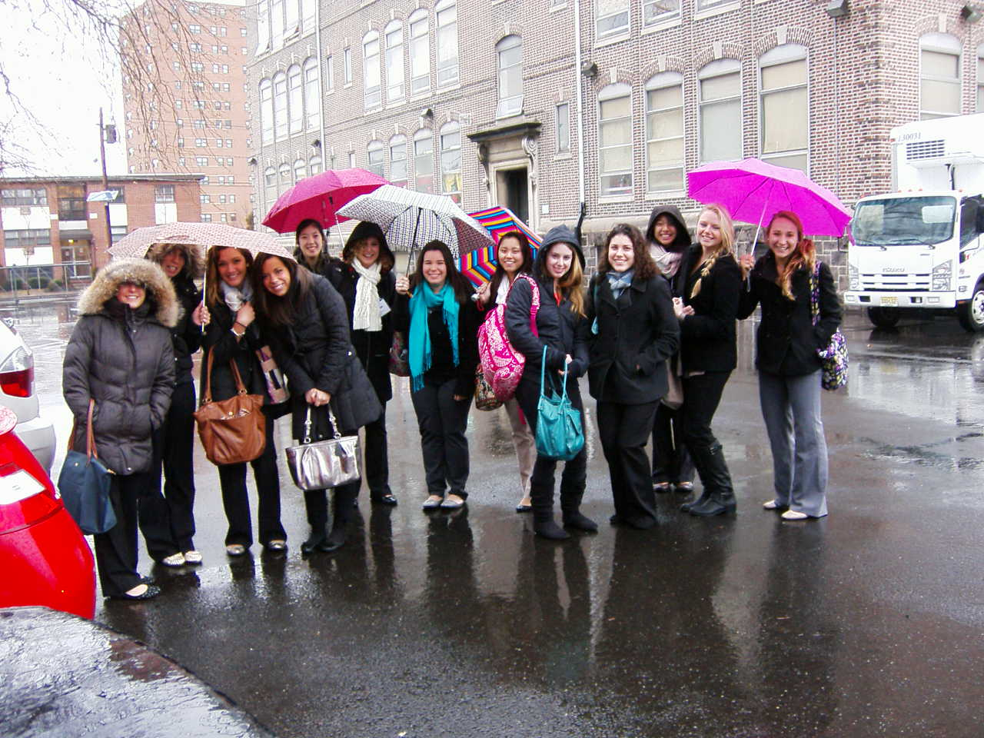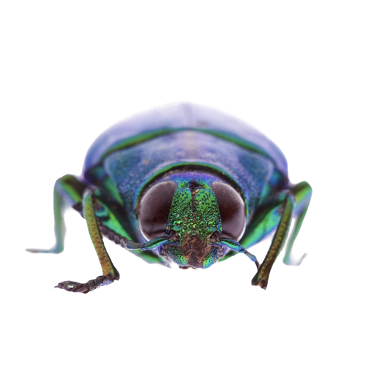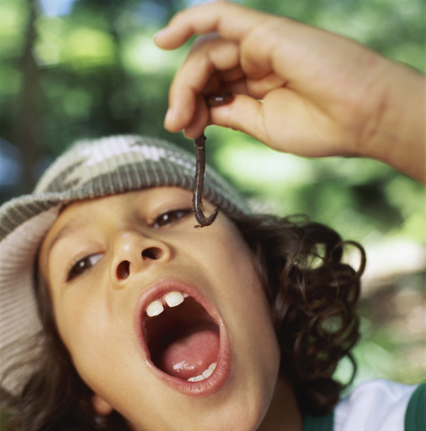

Continued on page 4

An inside look at Dr. Pan’s class attending Robbins Elementary

Friday, Febrary 22nd

On February 8th, Dr. Pan’s ACB students began their first day of a new semester of field experiences at Carroll Robbins Elementary School in Trenton, New Jersey. Although it was unfortunately a rainy day, we teachers-in-training were not going to let anything get us down on this special and exciting day! We met our cooperating teachers, who we all agreed were extremely warm, welcoming, and thrilled to have us in their classrooms! We also had the opportunity to meet the students in our classes, ranging from first-graders to third-graders, bilingual to solely English-speaking students. The students seemed just as happy to have us there as we were to be there!

## Ready to Learn at Robbins Elementary

Inside

Welcome to Robbins Elementary!

### Once Upon A Time…

Take a look at how the second graders are learning about fairytales! Find out what our class’ favorite fairytales are!

### President’s Day

Find out what teachers and students are doing at Robbins Elementary to celebrate this special day!

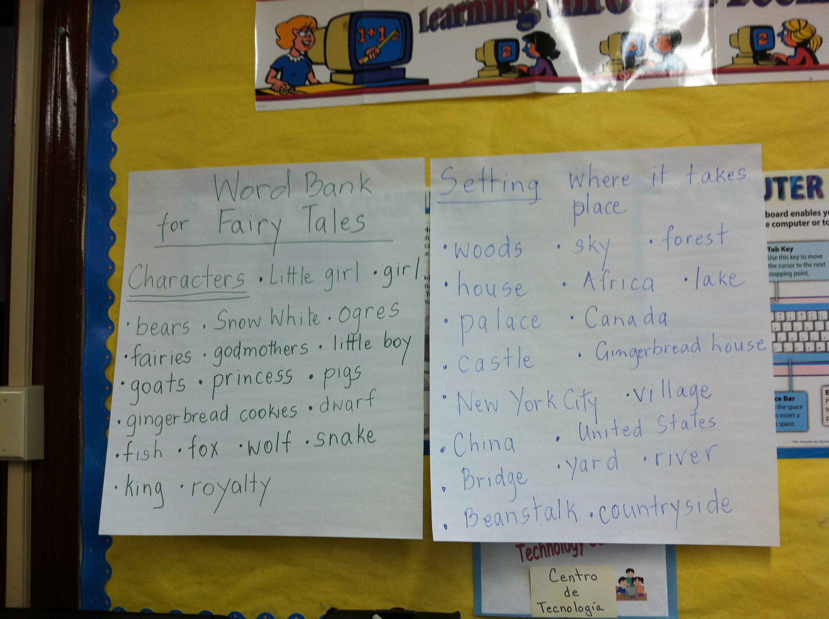

### Once Upon A Time…

Fairytales

In Mrs. Vasquez’s bilingual and Mrs. Masterson’s regular second-grade classrooms at Robbins Elementary, magical things are happening! These seven- and eight-year-olds are busy working on their literature unit on fairy tales! These little princes and princesses have been learning about many different aspects of a plethora of fairy tales, some of which include “Snow White”, “Cinderella”, and “The Three Little Pigs”. The students have studied many different aspects of fairy tales, including naming characters and settings in the books they have read and listing them all in a word bank, and naming the “Major Challenge” and their “Response” in tales such as “Jack and the Beanstalk”. Mrs. Vasquez exposed her students to many different versions of fairy tales from around the world, such as the African version of Cinderella entitled *Mufaro’s Beautiful Daughters* by John Steptoe, and then showed the students on a map of the world the different countries where the versions of the fairy tales have been written. This gives the students a better global perspective about where the fairy tales they are reading are coming from.

One of the most exciting activities that students in Mrs. Vasquez’s class are working on is reader’s theater performances of some of their favorite fairy tales! The students were broken up into three separate groups, so that each student was cast in a role in one of three plays: “Cinderella”, “Little Red Riding Hood”, and “The Three Little Pigs”. The students practiced their roles by studying their scripts at home. In class this past Thursday (Valentine’s Day), Mrs. Vasquez, Mrs. A (the ESL teacher), and the student teachers helped each cast block out their plays, which the students then performed for their fellow classmates. Each student created a crown to wear with their character’s name on it, so that the audience would know which character each student was playing. Everyone had a great time acting out their reader’s theater plays! Some examples of the charts created, work accomplished, and activities done by the students can be seen in the pictures below.

In Mrs. Masterson’s class, students are focusing on how to paint a picture of the setting to their reader by using describing words. Students are using these skills to write their own fairytales in class. The students are really excited about this project and we can’t wait to see the finished product!

***byline*[Name]**

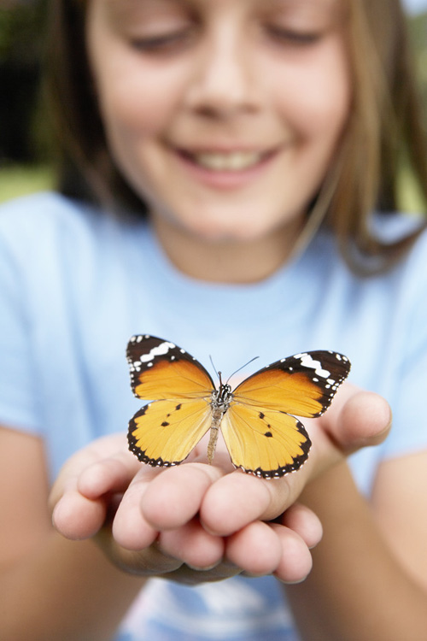

What do you say when you are comforting the grammar police?

**There, their, they’re**

**Sylvia:** Dad, can you write in the dark?

**Dad:** I think so. What do you want me to write?

**Sylvia:** Your name on this report card.

You might be a teacher when out in public, you feel the urge to snap your fingers at children you do not know and correct their behavior.

**Teacher:** Where is your homework?

**Pupil:** I lost it fighting this kid who said you weren’t the best teacher in school.

**Teacher:** Class, we will have only a half day of school this morning.

**Class:** Hooray!

**Teacher:** We will have the other half this afternoon.

LOL!!!

Education Jokes

Courtesy of Teach HUB Joke of the Day

[**http://www.teachhub.com/teacher-joke-day**](http://www.teachhub.com/teacher-joke-day)

The administration at Robbins Elementary School has enacted a new reading program to be put into place in the classrooms this year in an effort to try and bring all students to be able to read on level. The new program is called American Reading Company, and focuses upon different colored leveled books being administered to each grade, students practicing reading at school and at home by filling out their “steps,” on their reading log, and one-on-one conferencing with their teacher in the classroom. One “step” is equivalent to fifteen minutes of silent reading, and all of the students have a reading log where they record and report these steps to the teacher, who then records and reports them to the school’s electronic record of all the students’ steps in the school. The reason the school has begun working with the program is to try and meet the goal of having all the students reading on-grade level, because right now only 10% of the student body is reading at the appropriate level for their grade.

We were able to explore this program in the second grade, in both Mrs. Masterson (non-bilingual) and Mrs. Vasquez’s (bilingual) classrooms. Mrs. Vasquez’s second-grade bilingual students, who range from Green (Kindergarten/First-Grade level) to White (Third-Grade level) on the reading level chart, spend the first part of their morning independently reading books at their level for thirty minutes, which equals two steps on their reading log. Mrs. Masterson’s students also spend 30 minutes a day silently reading, and also log two steps on their reading log at school on a daily basis, but they read a little later in the day. Both Mrs. Masterson’s and Mrs. Vasquez’s second-grade classes have students who range from Green (Kindergarten/First-Grade level) to White (Third-Grade level) on the reading level chart. The variation in reading level is one of the challenges these teachers face in the classroom, but there is nothing more rewarding than seeing a child climb the ladder of reading levels and really make progress! Mrs. Vasquez and Mrs. Masterson, along with many other teachers, are currently learning how to conference with students in accordance with this new reading program. We are very excited to see how far the students will have come with their reading levels by the time the end of the semester comes.

##### Robbins Elementary Begins New Leveled-Reading Program



Susan DaQuila, Bryanna Kirner, and Christine Joannidis

Danielle R. and Susan led a class-wide reading of a President’s Day-themed Scholastic Weekly Reader with Mrs. Vasquez’s second-grade bilingual students.

On this past Monday, February 18th, Robbins Elementary School was closed in honor of President’s Day. However, during the previous week, many teachers and students at the school celebrated this special day with many activities commemorating our nation’s leaders, both past and present. Some of Dr. Pan’s students filled us in on how they celebrated President’s Day with their students. Check out their answers below!

Allison and Valerie plan on reading a story to their students about George Washington in honor of President’s Day during their field experience this week.

Michelle D. and Kelly split Mrs. Soles’ second-grade bilingual class into two groups, in which one group read a book about George Washington and the other group read a book about Abraham Lincoln. Then, each group made fact sheets and paper dolls of both George Washington and Abraham Lincoln.

Jessica and Kathy read a book about the White House to Ms. Canals’ first-grade bilingual students.

Continued from page 1

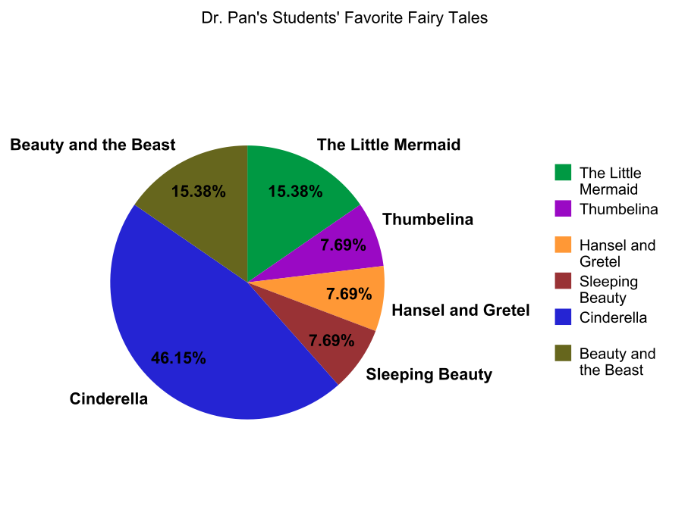

Dr. Pan’s Students’ Favorite Fairy Tales

Susan DaQuila and Danielle R. had a great first day experience. Susan informed us that, “I thought our first day went wonderfully! Our co-operating teacher is so welcoming and has allowed us to interact and work with our students so much already!”

By the end of the first two weeks of practicum experience, each of us will already have completed our “All About Me” book lessons and activities, as well as receive our unit topics from our co-operating teachers. We are all already working hard and making the most of our experience at Robbins Elementary. Keep up the good work, everyone! This will surely be a valuable experience for all of us.

Where we are at Robbins Elementary:

Jessie and Kathy – Ms. Canals’ bilingual first grade

Michelle S. and Sabrina– Ms. Ayling’s first grade

Heather and Bianca – Ms. Tindall’s first grade

Bryanna and Christine – Mrs. Masterson’s second grade

Susan and Danielle R. – Ms. Vasquez’s bilingual second grade

Michelle D. and Kelly – Ms. Soles’ bilingual second grade

Ashley and Danielle – Ms. Estrada’s bilingual third grade

Allison and Valerie – Ms. Delgado’s third grade